EXPERT SYSTEM  
FOR MENTAL HEALTH CLINIC

CS5346

SPRING 2020

PROJECT 1

By Satish Mallikarjuna Padaganur

A05006271

CONTENTS

|  |  |  |
| --- | --- | --- |
| SERIAL | SECTION | PAGE |
| NUMBER |  | NUMBER |
| 1. | ABSTRACT | 3 |
|  |  |  |
| 2. | TEAM MEMBERS CONTRIBUTION | 4 |
|  |  |  |
| 3. | EXPERT SYSTEM DESCRIPTION | 5 |
|  |  |  |
| 4. | PROBLEM STATEMENT | 6 |
|  |  |  |
| 5. | SOLUTION TO PROBLEM | 7 |
|  |  |  |
| 6. | PROJECT OVERVIEW | 8 |
|  |  |  |
| 7. | BACKWARD CHAINING DESCRIPTION | 9 |
|  |  |  |
| 8. | BACKWARD CHAINING DECISION TREE | 16 |
|  |  |  |
| 9. | BACKWARD CHAINING ALGORITHM | 17 |
|  |  |  |
| 10. | BACKWARD CHAINING RULES | 18 |
|  |  |  |
| 11. | FORWARD CHAINING DESCRIPTION | 21 |
|  |  |  |
| 12. | FORWARD CHAINING DECISION TREE | 24 |
|  |  |  |
| 13. | FORWARD CHAINING ALGORITHM | 25 |
|  |  |  |
| 14. | FORWARD CHAINING RULES | 26 |
|  |  |  |
| 15. | CODE MODIFICATIONS | 27 |
|  |  |  |
| 16. | ANALYSIS OF PROGRAM | 28 |
|  |  |  |
| 17. | ACRONYMS USED IN THE PROJECT | 29 |
| 18. | SOURCE CODE | 31 |
|  |  |  |
| 19. | TEST RESULTS | 51 |
|  |  |  |

ABSTRACT

The project is designed to simulate an expert system for a mental health clinic, consisting of the knowledge base and inference engine. The design highlights are the backward and forward chaining inference engines used for diagnosing mental disorders based on patients’ different symptoms and based on the disease inferring the required treatment respectively.

This system is mainly built to allow the Psychologists in clinics to diagnose the mental disorder of a patient and retrieve the treatment.

Explained in this report are the steps for each type of inference engine i.e., backward chaining and forward chaining, along with the logic and algorithms used. Also, included is the code used for the interface, which was performed in CodeBlocks tool using C++ language.

The code was developed in accordance to the problem statement and with help of the sample code provided by Dr. Moonis Ali.

TEAM MEMBERS CONTRIBUTION

This project was brought to life with a team effort. The team members involved are:

* Nagendra Kammari
* Rohit Goud Lode
* Satish Mallikarjuna Padaganur

The contributions made to the project by each team member are as follows:

* All of us together worked on building the knowledge base, by gathering various symptoms of a mental disorder and their treatment.
* We (Rohit, Nagendra, Satish) then worked on building the rules (IF-THEN statements) for backward chaining and Forward Chaining.
* Nagendra prepared decision trees based on finalized rules- which were developed in our group discussion.
* Satish prepared variables, conclusion and clause variable list for backward and forward chaining.
* We analyzed the sample code provided to us and eliminated the unnecessary parts of code.
* Rohit and Nagendra worked on coding the backward chaining, used for diagnosing the mental disorders based on the symptoms.
* Satish worked on the forward chaining code, used for finding the treatment for the respective mental disorders.
* Rohit and Satish did additional changes in the forward and backward chaining decision rules and trees.
* Rohit did modifications to backward chaining code and added paths in final decision trees.
* Nagendra then worked on combining and integrating the forward and backward chaining codes and attempted to optimize wherever possible.
* Rohit designed User Interface to the system with options and user read outs to make the system more user-friendly.
* Nagendra verified each function and came up with errors in the code.
* Rohit and Satish ran and tested the code to verify the correctness of all functionalities.

EXPERT SYSTEM DESCRIPTION

An expert system is a computer program that uses artificial intelligence (AI) technologies to simulate the judgment and behavior of a human or an organization that has expert knowledge and experience in a particular field.

Typically, an expert system incorporates a knowledge base containing accumulated experience and an inference or rules engine -- a set of rules for applying the knowledge base to each particular situation that is described to the program. The system's capabilities can be enhanced with additions to the knowledge base or to the set of rules. Current systems may include machine learning capabilities that allow them to improve their performance based on experience, just as humans do.

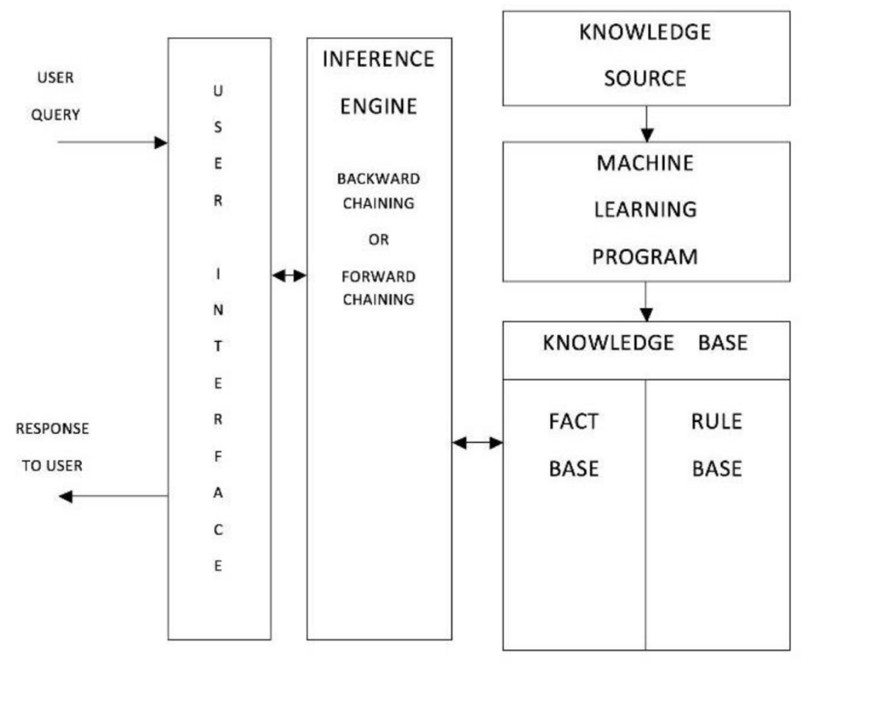

The inference engine is of two types, based on: Backward chaining (rule based) and Forward chaining (fact based).

Expert systems have played a large role in many industries including in financial services, telecommunications, healthcare, customer service, transportation, video games, manufacturing, aviation and written communication. Two early expert systems broke ground in the healthcare space for medical diagnoses.

PROBLEM STATEMENT

Create an intelligent computer expert system for mental health clinic to diagnose mental disorders and to recommend the treatment based on the diagnosis. Perform research using google search engine or any other source(psychiatrists) to collect knowledge about the symptoms caused by mental disorders as well as their treatments. The mental health clinic staff will feed the symptoms of the patient. Using Backward Chaining, your expert system will diagnose the mental disorder and then using Forward Chaining, it will recommend the treatment. After collecting knowledge, develop a decision tree for Backward Chaining and a decision tree for the Forward Chaining. Then transform the decision trees into rules. The rules should contain variables. Implement the expert system program, employing Backward Chaining and Forward Chaining methodologies. The backward chaining will diagnose the mental disorders and forward chaining will provide the treatment.

Develop a user-friendly interface, which receives input data from a mental health clinic staff in restricted English format, uses keyword matching, and responds in a restricted English format.

The inference engine programs are provided to you, but they are inefficient and erroneous. Instead of blindly using the inference engine programs, you must study them and modify them to make them as good as possible. In fact, you need to rewrite them. Rewrite these programs in C++ by employing Software Engineering principles which prohibits ‘GO TO’ statements and discourage global variable. Separate Knowledge base and Inference Engine parts of each program and bring efficiency in functionality and output using your creativity. Though you can totally rewrite the programs, they must be based on the methodologies used in these programs.

Your ‘main’ function will call the two other functions, i.e., ‘Identify Mental Disorder’ based on backward chaining and ‘Treatment’ based on forward chaining.

SOLUTION TO PROBLEM

In accordance to the problem statement the following are the solutions:

* Gather the knowledge base, the list of mental disorders and the associated symptoms and treatments list.
* Convert the mental disorders and their symptoms into IF-THEN rules for the backward chaining rule base.
* Similarly, make rules using mental disorders and their treatments for forward chaining rule base.
* Develop decision trees for both backward and forward chaining for the flow of path.
* Decide on the data structures for both inference engines.
* Analyze the given sample code with teammates.
* Modify the provided code for both backward and forward chaining programs.
* In the process optimize the code by removing bugs.
* Attempt to segregate code.
* Combine both portions of code to develop the final expert system with the interface, where the main function calls both parts.
* The final system must accept symptoms from user, infer the mental disorders and based on that display the treatment recommended efficiently.

PROJECT OVERVIEW

The expert system designed is helpful in the medical field, in mental health clinic.

When a patient who has possible symptoms of mental disorders, this system aids nurses or any medical experts to run a fast diagnosis on the patients.

The nurse(say) can then gather the symptoms from the patient and submit the observations in the program. the program will then infer what the mental disorder potentially could be, based on its knowledge.

The associated treatment for that mental disorder would be shown as the result for the nurse, if listed in the program.

Then the nurse can now come to decision about the disorder and submit the documents to doctor and recommend the patient to consult the doctor.

BACKWARD CHAINING DESCRIPTION

Backward chaining (or backward reasoning) is an inference method described as working backward from the goal. It is used in automated theorem provers, inference engines, proof assistants, and other artificial intelligence applications.

The data structures used in backward chaining are:

* **Clause Variable list:**

Clause variable list stores all the variables used in IF part of the rules. These variables are stored in array with four array slots as buffer. If only one or two array slots are filled, the remaining slots are left blank. If all the clauses in the IF part of a rule are connected by the logical

operator AND, all the variables in these clauses must be instantiated before the THEN part can be executed.

We can calculate the Clause variable number using the formula Clause_Number=4*((Rule_Number/10)-1) + 1.

For example, if rule number is 20 then the clause number for the rule number is 4*((20/10)-1)+1 = 5.

* **Conclusion Stack:**

Conclusion stack is the most important data structure in implementing backward chaining. It tells which rule contains the conclusion that we are trying to reach and which clause number in the IF portion is currently examined for instantiated.

* **Conclusion List:**

Conclusion list consists of the consequents (THEN part). A clause variable pointer keeps track of the current rule and currently executed clause in that rule. It consists of rule number, conclusion associated with that rule number and set of conditions which yields the conclusion. Conclusion list is complete when the THEN portion of each rule is placed in the same row as the rule number. If the IF part of a rule is true, we invoke the THEN part and instantiate the conclusion.

* **Variable** **List:**

This Data structure contains two items: variable name for each variable contained in the IF part of the knowledge base rules and the other item tells us whether the variable is instantiated. A variable only appears once in the list no matter how many condition clauses it appears. The instantiated column is always initially set to not instantiated (NI). It will be changed to instantiated (I) as each variable is set to a value.

The data structures used in this project are as follows:

**Variable List:**

|  |  |  |
| --- | --- | --- |
| **Clause No.** | **Clause Variable Name** | **Instantiated** |
| 1 | Behaviour_Change | NI |
| 2 | Anxious | NI |
| 3 | DISORDER | NI |
| 4 | Delusions | NI |
| 5 | Depression | NI |
| 6 | Concentration | NI |
| 7 | Class_II_Disorder | NI |
| 8 | Class_I_Disorder | NI |
| 9 | Exasperate | NI |
| 10 | Insomnia | NI |
| 11 | Apetite_Changes | NI |
| 12 | Fatigue | NI |
| 13 | Self_Destruct | NI |
| 14 | Dying_Fear | NI |
| 15 | Suicide | NI |
| 16 | Talkative | NI |
| 17 | Initial_Stage_Agoraphobia | NI |
| 18 | Panic_Attack | NI |
| 19 | Class_V_Disorder | NI |
| 20 | Initial_Stage_SchizoAffective | NI |
| 21 | Paranoia | NI |
| 22 | Manic_Depression | NI |
| 23 | Grandiosity | NI |
| 24 | Sex_Desire | NI |
| 25 | Class_III_Disorder | NI |
| 26 | Class_IV_Disorder | NI |
| 27 | Initial_Stage_Dysthymia | NI |
| 28 | Speech_Difficulty | NI |
| 29 | Initial_Stage_GAD | NI |
| 30 | Palpitation | NI |
| 31 | Initial_Stage_BiPolar | NI |
| 32 | Initial_Stage_DID | NI |
| 33 | Amnesia | NI |
| 34 | Initial_Stage_MDD | NI |
| 35 | Repeated_Thoughts | NI |
| 36 | Repeated_HeartBeat | NI |

**Clause-Variable List:**

|  |  |
| --- | --- |
| **Clause No.** | **Clause Variable Name** |
| 1 | Behaviour_Change |
| 2 |  |
| 3 |  |
| 4 |  |
| 5 | Behaviour_Change |
| 6 | Anxious |
| 7 |  |
| 8 |  |
| 9 | DISORDER |
| 10 | Delusions |
| 11 |  |
| 12 |  |
| 13 | DISORDER |
| 14 | Depression |
| 15 |  |
| 16 |  |
| 17 | DISORDER |
| 18 | Depression |
| 19 |  |
| 20 |  |
| 21 | Concentration |
| 22 | Class_II_Disorder |
| 23 |  |
| 24 |  |
| 25 | Class_I_Disorder |
| 26 | Exasperate |
| 27 |  |
| 28 |  |
| 29 | DISORDER |
| 30 | Insomnia |
| 31 | Concentration |
| 32 |  |
| 33 | DISORDER |
| 34 | Apetite_Changes |
| 35 | Fatigue |
| 36 |  |
| 37 | DISORDER |
| 38 | Self_Destruct |
| 39 | Dying_Fear |
| 40 |  |
| 41 | DISORDER |
| 42 | Self_Destruct |
| 43 | Dying_Fear |
| 44 |  |
| 45 | Class_II_Disorder |
| 46 | Suicide |
| 47 |  |
| 48 |  |
| 49 | DISORDER |
| 50 | Talkative |
| 51 |  |
| 52 |  |
| 53 | DISORDER |
| 54 | Talkative |
| 55 |  |
| 56 |  |
| 57 | Initial_Stage_Agoraphobia |
| 58 | Panic_Attack |
| 59 |  |
| 60 |  |
| 61 | Class_II_Disorder |
| 62 | Suicide |
| 63 |  |
| 64 |  |
| 65 | Suicide |
| 66 | Class_V_Disorder |
| 67 | Class_II_Disorder |
| 68 |  |
| 69 | Initial_Stage_SchizoAffective |
| 70 | Exasperate |
| 71 | Paranoia |
| 72 |  |
| 73 | Manic_Depression |
| 74 | Grandiosity |
| 75 | Sex_Desire |
| 76 |  |
| 77 | Manic_Depression |
| 78 | Grandiosity |
| 79 | Class_I_Disorder |
| 80 |  |
| 81 | Class_V_Disorder |
| 82 | Class_III_Disorder |
| 83 | Class_IV_Disorder |
| 84 |  |
| 85 | Initial_Stage_Dysthymia |
| 86 | Class_V_Disorder |
| 87 | Class_IV_Disorder |
| 88 | Suicide |
| 89 | Initial_Stage_Agoraphobia |
| 90 | Panic_Attack |
| 91 |  |
| 92 |  |
| 93 | Class_III_Disorder |
| 94 | Speech_Difficulty |
| 95 | Suicide |
| 96 |  |
| 97 | Initial_Stage_GAD |
| 98 | Palpitation |
| 99 |  |
| 100 |  |
| 101 | Initial_Stage_MDD |
| 102 | Speech_Difficulty |
| 103 |  |
| 104 |  |
| 105 | Initial_Stage_SchizoAffective |
| 106 | Paranoia |
| 107 |  |
| 108 |  |
| 109 | Initial_Stage_BiPolar |
| 110 | Class_I_Disorder |
| 111 | Class_III_Disorder |
| 112 |  |
| 113 | Initial_Stage_DID |
| 114 | Amnesia |
| 115 |  |
| 116 |  |
| 117 | Initial_Stage_MDD |
| 118 | Suicide |
| 119 | Repeated_Thoughts |
| 120 |  |
| 121 | Initial_Stage_MDD |
| 122 | Suicide |
| 123 | Repeated_HeartBeat |
| 124 |  |
| 125 | Initial_Stage_MDD |
| 126 | Suicide |
| 127 | Repeated_HeartBeat |
| 128 | Class_I_Disorder |

**Conclusion List:**

|  |  |
| --- | --- |
| **Rule No.** | **Variable Name** |
| 10 | NO_DISEASE |
| 20 | DISORDER |
| 30 | Class_I_Disorder |
| 40 | Class_II_Disorder |
| 50 | Class_I_Disorder |
| 60 | Class_III_Disorder |
| 70 | Initial_Stage_Dysthymia |
| 80 | Class_IV_Disorder |
| 90 | Class_V_Disorder |
| 100 | Suicide |
| 110 | Suicide |
| 120 | Initial_Stage_Agoraphobia |
| 130 | Grandiosity |
| 140 | Initial_Stage_SchizoAffective |
| 150 | Initial_Stage_GAD |
| 160 | Initial_Stage_DID |
| 170 | Initial_Stage_SchizoAffective |
| 180 | Manic_Depression |
| 190 | Initial_Stage_BiPolar |
| 200 | Disease |
| 210 | Initial_Stage_MDD |
| 220 | Disease |
| 230 | Disease |
| 240 | Disease |
| 250 | Disease |
| 260 | Disease |
| 270 | Disease |
| 280 | Disease |
| 290 | Disease |
| 300 | Disease |
| 310 | Disease |
| 320 | Disease |

BACKWARD CHAINING DECISION TREE

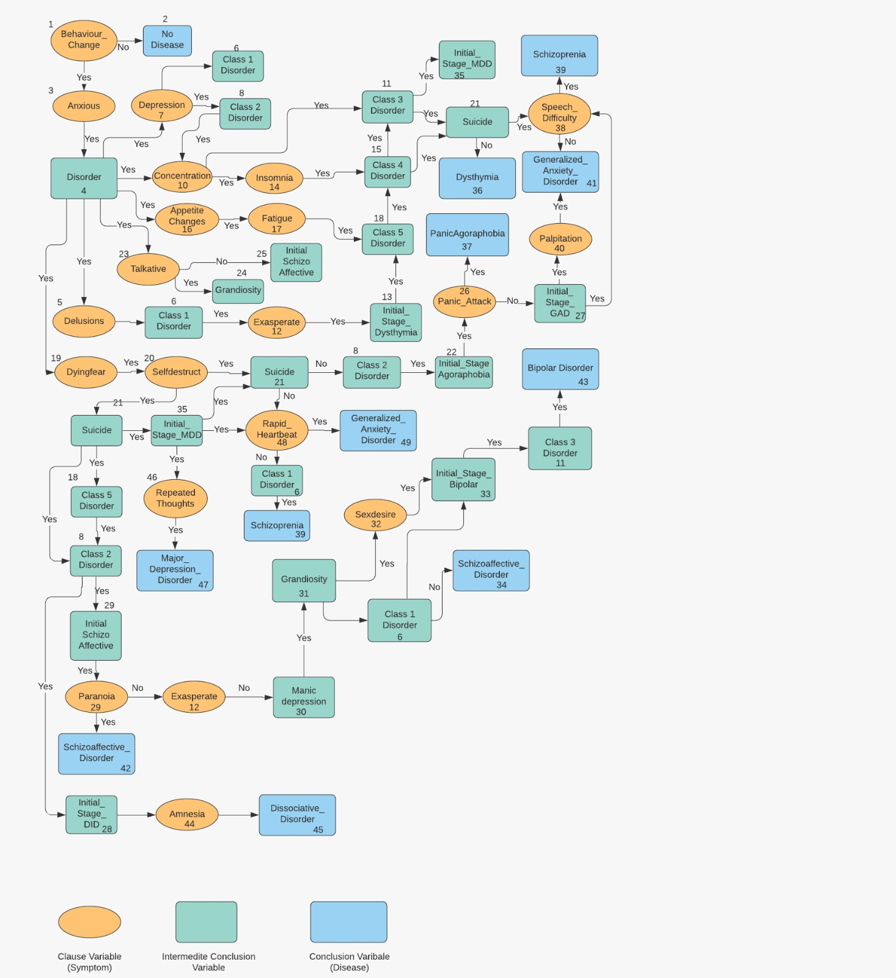

BACKWARD CHAINING ALGORITHM

Let us review the steps we have taken to implement the backward chaining structure:

* Identify the conclusion.
* Search the conclusion list for the first instance of the conclusion's name. If found, place the rule on the conclusion stack using the rule number and a (1) to represent the clause number. If not found, notify the user that an answer cannot be found.
* Instantiate the IF clause (i.e., each condition variable) of the statement. If one of the IF clause variables is not instantiated, as indicated by the variable list, and is not a conclusion variable, that is, not on the conclusion list, ask the user to enter a value.
* If one of the clauses is a conclusion variable, place the conclusion variable's rule number on the top of the stack and go back to step 3. If the statement on top of the stack cannot be instantiated using the present IF-THEN statement, remove the unit from the top of the stack and search the conclusion list for another instance of that conclusion variable's name.
* If such a statement is found, go back to step 3.
* If there are no more conclusions left on the conclusion stack with that name, the rule for the previous conclusion is false. If there is no previous conclusion, then notify the user that an answer cannot be found. If there is a previous conclusion, go back to step 6.
* If the rule on top of the stack can be instantiated, remove it from the stack. If another conclusion variable is underneath, increment the clause number, and for the remaining clauses go back to step 3. If no other conclusion variable is underneath, we have answered our question. The user can conclude.

BACKWARD CHAINING RULES

[Rule No.| Rule | Path]

10. IF Behaviour_Change = No 1, 2

THEN NO_DISEASE = Yes

20. IF Behaviour_Change = Yes AND Anxious = Yes 1, 3, 4

THEN DISORDER = Yes

30. IF DISORDER = Yes AND Delusions = Yes 4, 5, 6

THEN Class_I_Disorder = Yes

40. IF DISORDER = Yes AND Depression = Yes 4, 7, 8

THEN Class_II_Disorder = Yes

50. IF DISORDER = Yes AND Depression = No 4, 7, 6

THEN Class_I_Disorder = Yes

60. IF Concentration = Yes AND Class_II_Disorder = Yes 4, 8, 10, 11

THEN Class_III_Disorder = Yes

70. IF Class_I_Disorder = Yes AND Exasperate = Yes 6, 12, 13

THEN Initial_Stage_Dysthymia = Yes

80. IF DISORDER = Yes AND Insomnia = Yes AND Concentration = Yes 4, 10, 14, 15

THEN Class_IV_Disorder = Yes

90. IF DISORDER = Yes AND Apetite_Changes = Yes AND Fatigue = Yes 4,16,17,18

THEN Class_V_Disorder = Yes

100. IF DISORDER = Yes AND Dying_Fear = Yes AND Self_Destruct = Yes 4,19,20,21

THEN Suicide=Yes

110. IF DISORDER = Yes AND Dying_Fear = No AND Self_Destruct = No 4,19,20,21

THEN Suicide=No

120. IF Suicide = No AND Class_II_Disorder=Yes 8, 21, 22

THEN Initial_Stage_Agoraphobia = Yes

130. IF DISORDER = Yes AND Talkative = Yes 4, 23, 24

THEN Grandiosity = Yes

140. IF DISORDER = Yes AND Talkative = No 4, 23, 25

THEN Initial_Stage_SchizoAffective = Yes

150. IF Initial_Stage_Agoraphobia = Yes AND Panic_Attack = No 22,26,27

THEN Initial_Stage_GAD = Yes

160. IF Suicide = Yes AND Class_II_Disorder =Yes 8,21,28

THEN Initial_Stage_DID = Yes

170. IF Suicide = Yes AND Class_V_Disorder=Yes and Class_II_Disorder = Yes

THEN Initial_Stage_SchizoAffective = Yes 8,18,21,25

180. IF Initial_Stage_SchizoAffective = Yes AND Paranoia = No AND Exasperate = No

THEN Manic_Depression = Yes 12,25,29,30

190. IF Manic_Depression = Yes AND Grandiosity = Yes AND Sex_Desire = Yes

THEN Initial_Stage_BiPolar = Yes 30,31,32,33

200. IF Manic_Depression = Yes AND Grandiosity = No AND Class_I_Disorder = No

THEN Disease = SchizoAffective 6,30,31,34

210. IF Class_V_Disorder=Yes AND Class_IV_Disorder=Yes AND Class_III_Disorder = Yes

THEN Initial_Stage_MDD = Yes 11,15,18,35

220. IF Initial_Stage_Dysthymia = Yes AND Class_V_Disorder = Yes AND Class_IV_Disorder = Yes AND Suicide = No

THEN Disease = Dysthymia 13,15,18,21,36

230. IF Initial_Stage_Agoraphobia = Yes AND Panic_Attack = Yes 22,26,37

THEN Disease = Agoraphobia

240. IF Class_III_Disorder = Yes AND Suicide = Yes AND Speech_Diificulty = Yes

THEN Disease = SchizoPhrenia 11,21,38,39

250. IF Initial_Stage_GAD = Yes AND Palpitation = Yes 27,40,41

THEN Disease = GAD

260. IF Initial_Stage_GAD = Yes AND Speech_Diificulty = No 27,38,41

THEN Disease = GAD

270. IF Initial_Stage_SchizoAffective = Yes AND Paranoia = Yes 25,29,42

THEN Disease = SchizoAffective

280. IF Initial_Stage_Bipolar = Yes AND Class_I_Disorder = Yes AND Class_III_Disorder = yes

THEN Disease = Bi-Polar_Disorder 6,11,33,43

290. IF Initial_Stage_DID = Yes AND Amnesia = Yes 28, 44, 45

THEN Disease = DID

300. IF Initial_Stage_MDD = Yes AND Suicide= Yes AND Repeated_Thoughts = Yes

THEN Disease = MDD 21,35,46,47

310. IF Initial_Stage_MDD = Yes AND Suicide = No AND Repeated_HearBeat = Yes

THEN Disease = GAD 21,35,48,49

320. IF Initial_Stage_MDD = Yes AND Suicide= No AND Repeated_HearBeat = No AND Class_I_Disorder = Yes

THEN Disease = SchizoPhrenia 21,35,48,6,39

FORWARD CHAINING DESCRIPTION

Forward chaining is a popular implementation strategy for expert systems, business and production rule systems. The opposite of backward chaining.

Forward chaining starts with the available data and uses inference rules to extract more data (from an end user, for example) until a goal is reached.

The data structures used in backward chaining are:

* **Clause Variable list:**

The clause variable list stores the antecedents (IF part). We can calculate the Rule number using the formula

Rule_Number = (Quotient (Clause_Number /4) +1) *10.

* **Conclusion Variable Queue:**

Variable on which we are working is placed on conclusion variable queue and are served on first come first serve basis.

* **Clause Variable Pointer:**

It keeps track of clause within the rule being examined. It’s used to keep track of the rule and the clause within the rule being processed.

* **Variable List:**

The variable list is used to know whether the variable is instantiated or not instantiated. When user enters some information for a variable, then it is instantiated, and the answer given by the user is stored as a third field called Value.

The data structures used in this project are as follows:

**Variable List:**

|  |  |  |
| --- | --- | --- |
| **Clause No.** | **Clause Variable Name** | **Instantiated** |
| 1 | Disease | NI |

**Clause-Variable List:**

|  |  |
| --- | --- |
| **Clause No.** | **Clause Variable Name** |
| 1 | Disease |
| 2 |  |
| 3 |  |
| 4 |  |
| 5 | Disease |
| 6 |  |
| 7 |  |
| 8 |  |
| 9 | Disease |
| 10 |  |
| 11 |  |
| 12 |  |
| 13 | Disease |
| 14 |  |
| 15 |  |
| 16 |  |
| 17 | Disease |
| 18 |  |
| 19 |  |
| 20 |  |
| 21 | Disease |
| 22 |  |
| 23 |  |
| 24 |  |
| 25 | Disease |
| 26 |  |
| 27 |  |
| 28 |  |
| 29 | Disease |
| 30 |  |
| 31 |  |
| 32 |  |
| 33 | Disease |
| 34 |  |
| 35 |  |
| 36 |  |

**Conclusion-Variable Queue:**

|  |  |
| --- | --- |
| **Rule No.** | **Variable Name** |
| 10 | No_Treatment |
| 20 | Treatment |
| 30 | Treatment |
| 40 | Treatment |
| 50 | Treatment |
| 60 | Treatment |
| 70 | Treatment |
| 80 | Treatment |
| 90 | Treatment |

FORWARD CHAINING DECISION TREE

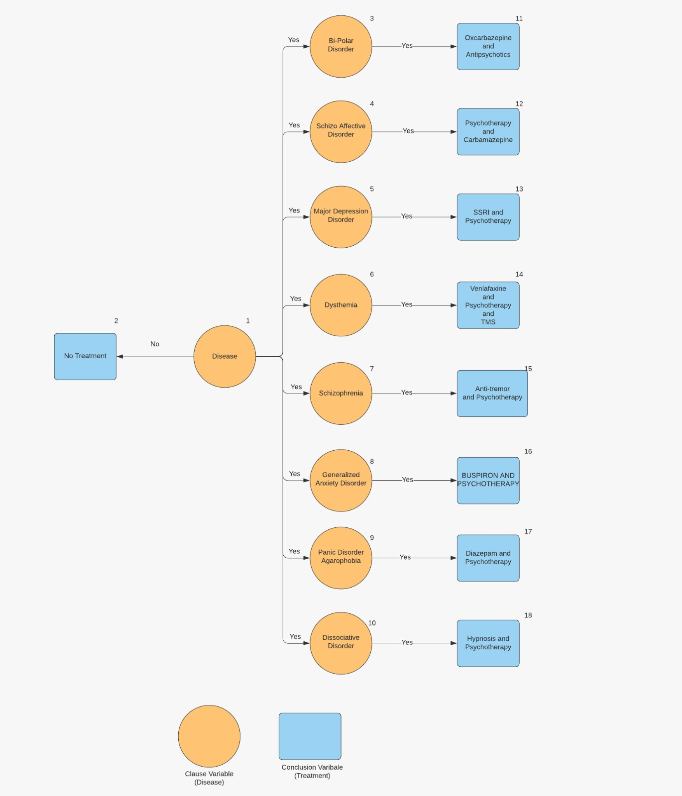

FORWARD CHAINING ALGORITHM

Let us review the steps we have taken to implement the forward chaining structure:

* The condition is identified.
* The condition variable is placed on the conclusion variable queue and its value is marked on the variable list.
* The clause variable list is searched for the variable whose name is the same as the one in the front of the queue. If found, the rule number and a 1 are placed into the clause variable pointer. If not found, go to step 6.
* Each variable in the IF clause of the rule that is not already instantiated is now instantiated. The variables are in the clause variable list. If all the clauses are true, the THEN part is invoked.
* The instantiated THEN part of the variable is placed in the back of the conclusion variable queue.
* When there are no more IF statements containing the variable that is at the front of the conclusion variable queue, that variable is removed.
* If there are no more variables on the conclusion variable queue, end the session. If there are more variables, go to step 3.

We can use the above concepts to design, in C++, a simple forward chaining expert tool.

FORWARD CHAINING RULES

[Rule No.| Rule | Path]

10. IF Disease = NO_DISEASE 1, 2

THEN No_Treatment = Yes

20. IF Disease = Bi-Polar Disorder 1, 3, 11

THEN Treatment = Oxcarbazepine and Antipsychotics

30. IF Disease = Schizoaffective Disorder 1, 4, 12

THEN Treatment = Psychotherapy and Carbamazepine

40. IF Disease = Major Depression Disorder 1, 5, 13

THEN Treatment = SSRI and Psychotherapy

50. IF Disease = Dysthymia 1, 6, 14

THEN Treatment = Venlafaxine and Psychotherapy and TMS

60. IF Disease = Schizophrenia 1, 7, 15

THEN Treatment = Anti-tremor and Psychotherapy

70. IF Disease = Generalized Anxiety Disorder 1, 8, 16

THEN Treatment = Anti-tremor and Psychotherapy

80. IF Disease = Panic Disorder Agoraphobia 1, 9, 17

THEN Treatment = Diazepam and Psychotherapy

90. IF Disease = Dissociative Disorder 1, 10, 18

THEN Treatment = Hypnosis and Psychotherapy

CODE MODIFICATIONS

* The major code modifications done are that code was written in C++.
* GOTO statements, i.e., jump statements were removed.
* The main function was separated from the backward and forward chaining parts;
* The main function was made to implement a main menu for the expert system, and the backward part is called backwardChaining.h. The forward part is called forwardChaining.h.
* A stack was implemented in the backward code. This stack is conclusion stack, which maintains rule number and clause number.
* The forward code was calling a Queue. H header file which represents the conclusion variable queue.
* Erroneous code was removed.
* Variables list was saved in an HashMap in the form of key and value pairs. Key is variable names and Instantiation is the value corresponding to the key.
* Conclusion List and clause variable List were also stored using an HashMap to optimize time complexity.
* The code is modularized using class hierarchy, where backward chaining and forward chaining classes have different functions to perform different actions; such as printing variable, conclusion and clause list, calculating rule numbers based on clause numbers and vice versa.

ANALYSIS OF PROGRAM

* The program displays a main menu.
* This system is made more user friendly, with read out displays which aids user to pick appropriate choices.
* It gives the user several options, from which a use can pick different option every time.
* There are additional options to display the individual data structures for each inference type as well.
* In this project, treatment and diagnosis are called at once, so as to make the user feel the power of our Expert AI System.

ACRONYMS USED IN THE PROJECT

|  |  |
| --- | --- |
| **Acronym** | **Meaning** |
| AX | Anxious |
| DI | DISORDER |
| DL | Delusions |
| EX | Exasperate |
| DP | Depression |
| SU | Suicide |
| PR | Paranoia |
| CC | Concentration |
| IN | Insomnia |
| AC | Appetite_Changes |
| FG | Fatigue |
| SD | Selfdestruct |
| DF | Dyingfear |
| SP | Speech_Difficulty |
| TL | Talkative |
| GD | Grandiosity |
| MD | Manicdepression |
| SX | Sexdesire |
| PA | Panic_Attack |
| AM | Amnesia |
| RT | Repeatedlygoingoverthoughts |
| RH | Rapid_Heartbeat |
| PP | PALPITATION |
| ADL | CLASS1DISORDER |
| AD | CLASS2DISORDER |
| ID | INITIAL_STAGE_DYSTHYMIA |
| IC | CLASS4DISORDER |
| CD | CLASS3DISORDER |
| AF | CLASS5DISORDER |
| IA | INITIAL_STAGE_PANICDISORDERAGROPHOBIA |
| SU | SUICIDE |
| IG | INITIAL_STAGE_GENERALIZED_ANXIETY_DISORDER |
| IS | INITIAL_STAGE_SCHIZOAFECTIVE_DISORDER |
| MD | MANICDEPRESSION |
| GD | GRANDIOSITY |
| IB | INITIAL_STAGE_BIPOLAR_DISORDER |
| IM | INITIAL_STAGE_MDD |
| TP | Disease |
| ND | NO_DISEASE |

SOURCE CODE

#include <iostream>

#include <map>

#include<stack>

#include <cmath>

#include <queue>

#include<bits/stdc++.h>

**using** **namespace** std;

**class** backwardChaining{

**private**:

map<**int**, string> concList;

map<string,**int**> Li;

map<string, **int**> visited;

map<string, **int**> store;

map<string, string> Questions;

map<**int**, string> clausList;

map<string, **int**> concVar;

**public**:

backwardChaining(){

concList[10] = "DI";

concList[20] = "DI";

concList[30] = "ADL";

concList[40] = "AD";

concList[50] = "AD";

concList[60] = "CD";

concList[70] = "ID";

concList[80] = "IC";

concList[90] = "AF";

concList[100] = "SU";

concList[110] = "SU";

concList[120] = "IA";

concList[130] = "GD";

concList[150] = "IS";

concList[140] = "IG";

concList[160] = "ID";

concList[170] = "IS";

concList[180] = "MD";

concList[190] = "IB";

concList[200] = "TP";

concList[210] = "IM";

concList[220] = "TP";

concList[230] = "TP";

concList[240] = "TP";

concList[250] = "TP";

concList[260] = "TP";

concList[270] = "TP";

concList[280] = "TP";

concList[290] = "TP";

concList[300] = "TP";

concList[310] = "TP";

concList[320] = "TP";

Li["DI"] = 10;

Li["DI"] = 20;

Li["ADL"] = 30;

Li["AD"] = 40;

Li["AD"] = 50;

Li["CD"] = 60;

Li["ID"] = 70;

Li["IC"] = 80;

Li["AF"] = 90;

Li["SU"] = 100;

Li["SU"] = 110;

Li["IA"] = 120;

Li["GD"] = 130;

Li["IS"] = 150;

Li["IG"] = 140;

Li["ID"] = 160;

Li["IS"] = 170;

Li["MD"] = 180;

Li["IB"] = 190;

Li["TP"] = 200;

Li["IM"] = 210;

Li["TP"] = 220;

Li["TP"] = 230;

Li["TP"] = 240;

Li["TP"] = 250;

Li["TP"] = 260;

Li["TP"] = 270;

Li["TP"] = 280;

Li["TP"] = 290;

Li["TP"] = 300;

Li["TP"] = 310;

Li["TP"] = 320;

store["BC"] = -1;

store["AX"] = -1;

store["DL"] = -1;

store["EX"] = -1;

store["DP"] = -1;

store["SU"] = -1;

store["PR"] = -1;

store["CC"] = -1;

store["IN"] = -1;

store["AC"] = -1;

store["FG"] = -1;

store["SD"] = -1;

store["DF"] = -1;

store["SP"] = -1;

store["TL"] = -1;

store["GD"] = -1;

store["MD"] = -1;

store["SX"] = -1;

store["PA"] = -1;

store["AM"] = -1;

store["RT"] = -1;

store["RH"] = -1;

store["PP"] = -1;

Questions["BC"] = "Is the person exhibiting any behavioral changes? (Enter Yes or No)";

Questions["AX"] = "Is the person anxious? (Enter Yes or No)";

Questions["DL"] = "Is the person having delusions? (Enter Yes or No)";

Questions["EX"] = "Is the person exasperate? (Enter Yes or No)";

Questions["DP"] = "Is the person suffering from depression? (Enter Yes or No)";

Questions["PR"] = "Is the person suffering from paranoia? (Enter Yes or No)";

Questions["CC"] = "Is the person having difficulty to concentrate? (Enter Yes or No)";

Questions["IN"] = "Is the person suffering from insomnia? (Enter Yes or No)";

Questions["AC"] = "Are there any appetite changes in the person? (Enter Yes or No)";

Questions["FG"] = "Is the person suffering from fatigue? (Enter Yes or No)";

Questions["SD"] = "Is the person exhibiting from self destructive behavior? (Enter Yes or No)";

Questions["DF"] = "Is the person suffering from dying fear? (Enter Yes or No)";

Questions["SP"] = "Is the person having any speech difficulties? (Enter Yes or No)";

Questions["TL"] = "Is the person talkative? (Enter Yes or No)";

Questions["SX"] = "Is the person having sex desire? (Enter Yes or No)";

Questions["PA"] = "Did the person have any panic attacks? (Enter Yes or No)";

Questions["AM"] = "Is the person suffering from amnesia? (Enter Yes or No)";

Questions["RT"] = "Is the person repeatedly going over thoughts? (Enter Yes or No)";

Questions["RH"] = "Is the person having rapid heartbeat? (Enter Yes or No)";

Questions["PP"] = "Is the person suffering from PALPITATION? (Enter Yes or No)";

clausList[1] = "BC";

clausList[5] = "BC";

clausList[6] = "AX";

clausList[9] = "DI";

clausList[10] = "DL";

clausList[13] = "DI";

clausList[14] = "DP";

clausList[17] = "DI";

clausList[18] = "DP";

clausList[21] = "CC";

clausList[22] = "AD";

clausList[25] = "ADL";

clausList[26] = "EX";

clausList[29] = "DI";

clausList[30] = "IN";

clausList[31] = "CC";

clausList[33] = "DI";

clausList[34] = "AC";

clausList[35] = "FG";

clausList[37] = "ID";

clausList[38] = "AF";

clausList[39] = "IC";

clausList[41] = "DI";

clausList[42] = "SD";

clausList[43] = "DF";

clausList[45] = "DI";

clausList[46] = "SD";

clausList[47] = "DF";

clausList[49] = "AD";

clausList[50] = "SU";

clausList[53] = "DI";

clausList[54] = "TL";

clausList[57] = "DI";

clausList[58] = "TL";

clausList[61] = "IA";

clausList[62] = "PA";

clausList[65] = "AD";

clausList[66] = "SU";

clausList[69] = "SU";

clausList[70] = "AF";

clausList[71] = "AD";

clausList[73] = "IS";

clausList[74] = "EX";

clausList[75] = "PR";

clausList[77] = "MD";

clausList[78] = "GD";

clausList[79] = "SX";

clausList[81] = "MD";

clausList[82] = "GD";

clausList[83] = "ADL";

clausList[85] = "AF";

clausList[86] = "CD";

clausList[87] = "IC";

clausList[89] = "IA";

clausList[90] = "PA";

clausList[93] = "CD";

clausList[94] = "SP";

clausList[95] = "SU";

clausList[97] = "IG";

clausList[98] = "PP";

clausList[101] = "IG";

clausList[102] = "SP";

clausList[105] = "IS";

clausList[106] = "PR";

clausList[109] = "IB";

clausList[110] = "ADL";

clausList[111] = "CD";

clausList[113] = "ID";

clausList[114] = "AM";

clausList[117] = "IM";

clausList[118] = "SU";

clausList[119] = "RT";

clausList[121] = "IM";

clausList[122] = "SU";

clausList[123] = "RH";

clausList[125] = "IM";

clausList[126] = "SU";

clausList[127] = "RH";

clausList[128] = "ADL";

visited["BC"] = 0;

visited["AX"] = 0;

visited["DI"] = 0;

visited["DL"] = 0;

visited["EX"] = 0;

visited["DP"] = 0;

visited["SU"] = 0;

visited["PR"] = 0;

visited["CC"] = 0;

visited["IN"] = 0;

visited["AC"] = 0;

visited["FG"] = 0;

visited["SD"] = 0;

visited["DF"] = 0;

visited["SP"] = 0;

visited["TL"] = 0;

visited["GD"] = 0;

visited["MD"] = 0;

visited["SX"] = 0;

visited["PA"] = 0;

visited["AM"] = 0;

visited["RT"] = 0;

visited["RH"] = 0;

visited["PP"] = 0;

visited["DI"] = 0;

visited["ID"] = 0;

visited["ADL"] = 0;

visited["IC"] = 0;

visited["CD"] = 0;

visited["AF"] = 0;

visited["IA"] = 0;

visited["SU"] = 0;

visited["IG"] = 0;

visited["IS"] = 0;

visited["MD"] = 0;

visited["GD"] = 0;

visited["IB"] = 0;

visited["IM"] = 0;

concVar["DI"] = -1;

concVar["ADL"] = -1;

concVar["AD"] = -1;

concVar["CD"] = -1;

concVar["ID"] = -1;

concVar["IC"] = -1;

concVar["AF"] = -1;

concVar["IA"] = -1;

concVar["SU"] = -1;

concVar["IG"] = -1;

concVar["IS"] = -1;

concVar["MD"] = -1;

concVar["GD"] = -1;

concVar["IB"] = -1;

concVar["IM"] = -1;

}

**public**:

**int** calc(**int** rule){

**int** k = 4*(rule/10-1)+1;

**return** k;

}

**int** calcClaus(**int** claus){

**return** floor((10*(claus-1+4)/4)/10)*10;

}

**void** printClausVariableList(map<string, string> abbr){

cout<<"****************** Clause Variable List ******************"<<endl;

**for**(**int** i=1;i<=32*4;i++){

cout<<"CLAUSE "<<i<<" "<<abbr[clausList[i]]<<endl;

}

}

**void** printVariableList(map<string, string> abbr){

**int** cnt =1;

cout<<"****************** Variable List ******************"<<endl;

**for**(**auto** **const**& i: store){

cout<<cnt++<<". "<<abbr[i.first]<<endl;

}

}

**void** printConcVariableList(map<string, string> abbr){

cout<<"******** Conclusion Variable List *************"<<endl;

**for**(**auto** **const**& i: concList)

cout<<i.first<<" "<<abbr[i.second]<<endl;

}

**void** printStore(map<string, **int**> store,map<string, **int**> concVar){

cout<<"Result Variables "<<endl;

**for**(**auto** **const**& i: store){

**if**(i.second==1)

cout<<i.first<<" "<<i.second<<endl;

}

cout<<"Conclusion Variables "<<endl;

**for**(**auto** **const**& j: concVar){

**if**(j.second==1)

cout<<j.first<<" "<<j.second<<endl;

}

}

string checkRuleSatisfied(**int** ruleNum, map<string, **int**> & store, map<string, **int**> &concVar){

string ans = "";

**if**(store["BC"] == 0 )

{

concVar["DI"] = 0;

ans="NO_DISEASE";

}

**if**( store["BC"] == 1 && store["AX"]==1 && concVar["DI"]==-1)

{

concVar["DI"] = 1;

cout <<" DISORDER "<<endl;

}

**if**( (store["BC"] == 0 && store["AX"]==0) || (store["BC"] == 1 && store["AX"]==0) || (store["BC"] == 0 && store["AX"]==1) )

{

concVar["SY"] = 0;

cout<<"NO_DISORDER"<<endl;

}

// if(store["SY"] = 0) {concVar["DI"] = 0; ans="NO_DISEASE";}

**if**( concVar["DI"]==1 && store["DL"] ==1 && concVar["ADL"] == -1)

{

concVar["ADL"] = 1;

cout<<" CLASS 1 DISORDER "<<endl;

}

**if**( concVar["DI"]==1 && store["DP"]==1 && concVar["AD"] ==-1)

{

concVar["AD"] =1;

cout<<" CLASS 2 DISORDER "<<endl;

}

**if**( concVar["DI"]== 1 && store["DP"]==0 )

concVar["AD"] = 0;

**if**( store["CC"] ==1 && concVar["AD"]==1 && concVar["CD"] == -1 )

{

concVar["CD"] = 1;

cout<<" CLASS 3 DISORDER "<<endl;

}

**if**( concVar["ADL"]==1 && store["EX"] == 1 && concVar["ID"]==-1)

{

concVar["ID"]=1;

cout<<"INITIAL STAGE DYSTHYMIA "<<endl;

}

**if**( concVar["DI"]==1 && store["IN"] == 1 && store["CC"] == 1 &&concVar["IC"]==-1 )

{

concVar["IC"]=1;

cout<<"CLASS 4 DISORDER "<<endl;

ans = "IC";

}

**if**( concVar["DI"]==1 && store["AC"] == 1 && store["FG"] == 1 && concVar["AF"]==-1)

{

concVar["AF"]=1;

cout<<"CLASS 5 DISORDER"<<endl;

ans = "AF";

}

**if**( concVar["DI"]==1 && store["SD"]==1 && store["DF"] ==1 && concVar["SU"]==-1)

{

concVar["SU"]=1;

cout<<"SUICIDE (SUICIDAL THOUGHTS) "<<endl;

ans = "SU";

}

**if**( concVar["DI"]==1 && store["SD"]==0 && store["DF"] == 0 )

{

concVar["SU"]=0;

}

**if**( concVar["AD"] ==1 && concVar["SU"] == 0 && concVar["IA"]==-1)

{

concVar["IA"]=1;

cout<<"INITIAL STAGE PANICDISORDERAGROPHOBIA "<<endl;

ans = "IA";

}

**if**( concVar["DI"] == 1 && store["TL"] == 1 && concVar["GD"] == -1)

{

concVar["GD"] = 1;

cout<<" GRANDIOSITY "<<endl;

ans = "GD";

}

**if**( concVar["DI"] == 1 && store["TL"] == 0 && concVar["IS"] == -1)

{

concVar["IS"] = 1;

cout<<" INITIAL STAGE SCHIZOAFECTIVE_DISORDER "<<endl;

}

**if**(concVar["IA"]==1 && store["PA"] == 0 && concVar["IG"]==-1)

{

concVar["IG"]=1;

cout<<"INITIAL STAGE GENERALIZED_ANXIETY_DISORDER "<<endl;

ans = "IG";

}

**if**(concVar["AD"]==1 && concVar["SU"]==1 && concVar["ID"]==-1 )

{

concVar["ID"]=1; DISSOCIATIVE

cout<<"INITIAL STAGE DISSOCIATIVEDISORDER "<<endl;

ans = "ID";

}

**if**( concVar["SU"] ==1 && concVar["AF"]==1 && concVar["AD"]==1 && concVar["IS"]==-1)

{

concVar["IS"]=1;

cout<<"INITIAL STAGE SCHIZOAFECTIVE_DISORDER"<<endl;

ans = "IS";

}

**if**( concVar["IS"]==1 && store["EX"]==0 && store["PR"]==0 && concVar["MD"]==-1)

{

concVar["MD"]=1;

cout<<"MANIC DEPRESSION"<<endl;

ans = "MD";

}

**if**( concVar["MD"]==1 && concVar["GD"]==1 && store["SX"] == 1 && concVar["IB"]==-1 )

{

concVar["IB"]=1;

cout<<"INITIAL STAGE BIPOLAR DISORDER "<<endl;

ans = "IB";

}

**if** (concVar["MD"] == 1 && concVar["GD"] == -1 && concVar["ADL"] == 0)

{

ans="SCHIZOAFECTIVE_DISORDER";

}

**if**( concVar["AF"]==1 && concVar["CD"] == 1 && concVar["IC"] == 1 && concVar["IM"]==-1)

{

concVar["IM"]=1;

cout<<"INITIAL STAGE MDD "<<endl;

ans = "IM";

}

**if**(concVar["ID"]==1 && concVar["AF"]==1 && concVar["IC"] == 1 && concVar["SU"]==0)

{

ans="DYSTHYMIA";

}

**if**(concVar["IA"]==1 && store["PA"] == 1 )

ans="PANICDISORDERAGROPHOBIA";

**if**( concVar["CD"]==1 && store["SP"]== 1 && concVar["SU"]==1 )

ans="SCHIZOPHRENIA";

**if**( concVar["IG"]==1 && store["PP"]==1 )

ans="GENERALIZED_ANXIETY_DISORDER";

**if**( concVar["IG"]==1 && store["SP"]== 0 )

ans="GENERALIZED_ANXIETY_DISORDER";

**if**( concVar["IS"]== 1 && store["PR"] == 1 )

ans="SCHIZOAFECTIVE_DISORDER";

**if**( concVar["IB"]==1 && concVar["AD"]==1 && concVar["CD"]==1 )

ans="BIPOLAR_DISORDER";

**if**( concVar["ID"]==1 && store["AM"] == 1 )

ans="DISSOCIATIVEDISORDER";

**if**( concVar["IM"]==1 && concVar["SU"] == 1 && store["RT"]==1 )

ans="MAJORDEPRESSDISORDER";

**if**( concVar["IM"]==1 && concVar["SU"]==0 && store["RH"] == 1 )

ans="GENERALIZED_ANXIETY_DISORDER";

**if**( concVar["IM"]==1 && concVar["SU"]==0 && store["RH"] == 0 && store["ADL"]==1)

ans="SCHIZOPHRENIA";

**return** ans;

}

string startProcess(map<string, string> abbr){

string finalAns = "";

string start = "";

cout<<"Do you want to start ? (Enter Yes / No) ";

cin>>start;

transform(start.begin(), start.end(), start.begin(), ::tolower);

**int** startResp = (start=="yes");

**if**(startResp==1){

stack<**int**> stk;

**for**(**auto** **const** &i: concList){

stk.push(i.first);

**int** c = 0;

**while**(!stk.empty()){

**if**(c>23){

**break**;

}

**int** rs = calc(stk.top());

**int** j =rs;

**int** cnt = 0;

**while** (j<rs+4){

string vr = clausList[j]; // Gets Variables of IF

**if**(visited[vr]==0){

visited[vr] = 1;

**if**(concVar.find(vr)!=concVar.end() && concVar[vr]==-1){

stk.push(Li[vr]);

**break**;

}**else**{

**if**(Questions.find(vr)!=Questions.end() && vr.length()>0){

cout<<Questions[vr]<<endl;

string answer = "";

cin>>answer;

transform(answer.begin(), answer.end(), answer.begin(), ::tolower);

**int** ansResp = (answer=="yes");

store[vr] = ansResp;

j++;

}**else**{

j++;

}

}

}**else**{

j++;

}

cnt+=1;

}

**if**(cnt==4) {

checkRuleSatisfied(stk.top(), store, concVar);

stk.pop();

}

c++;

}

string finl = checkRuleSatisfied(i.first, store, concVar);

**if**(finl=="" || concVar.find(finl)!=concVar.end()){

**continue**;

}**else**{

cout<<"****************************Success*********************"<<endl;

finalAns = finl;

cout<< "PATIENT IS SUFFERING FROM : "<<finl<<" DISORDER."<<endl;

**break**;

}

}

}

**return** finalAns;

}

};

**class** forwardChaining{

**private**:

map<string, string>store;

map<string, vector<**int**> >clausList;

vector<**int**>clsLi;

map<**int**,string> Li;

queue<string> qu;

**public**:

forwardChaining(){

store["DI"] = "-1";

vector<**int**>clsLi;

**for**(**int** i =1; i < 10; i++)

{

**int** j = 4 * (i-1) + 1;

clsLi.push_back(j);

}

clausList["DI"] = clsLi;

Li[1] = "DI";

}

**int** resClaus (**int** clausNum){ **return** (floor(clausNum/4)+1)*10;}

**int** getAnswers(**int** a, map<string,string> & store){

**int** ans=0;

**switch**(a){

**case** 10:

**if**(store["DI"]=="NO_DISEASE") {

cout<<"TREATMENT RECOMMENDED FOR THIS DISORDER : ";

cout<<"No Treatment"<<endl;

ans = 1;

**break**;

}

**case** 20:

**if**(store["DI"]=="BIPOLAR_DISORDER"){

cout<<"TREATMENT RECOMMENDED FOR THIS DISORDER : ";

cout<<"OXCARBAZEPINE AND ANTIPSYCHOTICS"<<endl;

ans = 1;

**break**;

}

**case** 30:

**if**(store["DI"]=="SCHIZOAFECTIVE_DISORDER"){

cout<<"TREATMENT RECOMMENDED FOR THIS DISORDER : ";

cout<<"PSYCHOTHERAPY AND CARBAMAZEPINE"<<endl;

ans = 1;

**break**;

}

**case** 40:

**if**(store["DI"]=="MAJORDEPRESSDISORDER"){

cout<<"TREATMENT RECOMMENDED FOR THIS DISORDER : ";

cout<<"SSRI AND PSYCHOTHERAPY"<<endl;

ans = 1;

**break**;

}

**case** 50:

**if**(store["DI"]=="DYSTHYMIA"){

cout<<"TREATMENT RECOMMENDED FOR THIS DISORDER : ";

cout<<"VENLAFAXINE AND PSYCHOTHERAPY AND TMS"<<endl;

ans = 1;

**break**;

}

**case** 60:

**if**(store["DI"]=="SCHIZOPHRENIA"){

cout<<"TREATMENT RECOMMENDED FOR THIS DISORDER : ";

cout<<"ANTI-TREMOR AND PSYCHOTHERAPY"<<endl;

ans = 1;

**break**;

}

**case** 70:

**if**(store["DI"]=="GENERALIZED_ANXIETY_DISORDER"){

cout<<"TREATMENT RECOMMENDED FOR THIS DISORDER : ";

cout<<"BUSPIRON AND PSYCHOTHERAPY"<<endl;

ans = 1;

**break**;

}

**case** 80:

**if**(store["DI"]=="PANICDISORDERAGROPHOBIA"){

cout<<"TREATMENT RECOMMENDED FOR THIS DISORDER : ";

cout<<"DIAZEPAM AND PSYCHOTHERAPY"<<endl;

ans = 1;

**break**;

}

**case** 90:

**if**(store["DI"]=="DISSOCIATIVEDISORDER"){

cout<<"TREATMENT RECOMMENDED FOR THIS DISORDER : ";

cout<<"HYPNOSIS AND PSYCHOTHERAPY"<<endl;

ans = 1;

**break**;

}

}

**return** ans;

}

**void** printVariableList(){

cout<<"************** VARIABLE LIST *************"<<endl;

cout<<"1. "<<"DISORDER "<<endl;

}

**void** printClausVariableList(){

cout<<"************** CLAUSE VARIABLE LIST *************"<<endl;

**for**(**int** i=1;i<=8*4;i++){

**if**(i%4==1)

cout<<"CLAUSE "<<i<<" "<<"DISORDER "<<endl;

**else**

cout<<"CLAUSE "<<i<<endl;

}

}

**void** printConcVariableList(){

cout<<"************** CONCLUSION VARIABLE LIST *************"<<endl;

**for**(**int** i=1;i<=8*4;i++){

cout<<"CONCLUSION "<<i<<" "<<"TREATMENT "<<endl;

}

}

string askQuestions(string question){

string ans="";

**if**(question=="DI") { cout<<"Which Disease?"<<endl;

cin>>ans;}

**return** ans;

}

**void** startFcProcess(string diagnosedDisease){

string question = "";

store["DI"] = diagnosedDisease;

qu.push("DI");

**int** cnt = 0;

**while**(!qu.empty()){

**if** (cnt>10) **break**;

string a = qu.front();

qu.pop();

**int** c = 0;

**int** siz = 0;

**while**(siz<clausList[a].size()){

c++;

**if**(c>50) {**break**;}

**int** cls = clausList[a][siz];

**int** i = cls;

**while**(i<cls+4){

**if**(store[Li[i]] == "-1"){

store[Li[i]] = askQuestions(Li[i]);

}

i++;

}

**if**(store[a]=="-1"){

store[a] = askQuestions(a);

}**else**{

**int** ans = getAnswers(resClaus(clausList[a][siz]), store); // Calculates all clause questions by calculating rules

**if**(ans==1)

**break**;

**else**{

siz++;

**continue**;

}

}

c++;

}

cnt++;

}

}

};

**int** main(){

map<string, string> abbr;

abbr["BC"] = "Behaviour_Change";

abbr["AX"] = "Anxious";

abbr["DI"] = "DISORDER";

abbr["DL"] = "Delusions";

abbr["EX"] = "Exasperate";

abbr["DP"] = "Depression";

abbr["SU"] = "Suicide";

abbr["PR"] = "Paranoia";

abbr["CC"] = "Concentration";

abbr["IN"] = "Insomnia";

abbr["AC"] = "Appetite_Changes";

abbr["FG"] = "Fatigue";

abbr["SD"] = "Selfdestruct";

abbr["DF"] = "Dyingfear";

abbr["SP"] = "Speech_Difficulty";

abbr["TL"] = "Talkative";

abbr["GD"] = "Grandiosity";

abbr["MD"] = "Manicdepression";

abbr["SX"] = "Sexdesire";

abbr["PA"] = "Panic_Attack";

abbr["AM"] = "Amnesia";

abbr["RT"] = "Repeatedlygoingoverthoughts";

abbr["RH"] = "Rapid_Heartbeat";

abbr["PP"] = "PALPITATION";

abbr["ADL"] = "CLASS 1 DISORDER";

abbr["AD"] = "CLASS 2 DISORDER";

abbr["ID"] = "INITIAL_STAGE_DYSTHYMIA";

abbr["IC"] = "CLASS 4 DISORDER";

abbr["CD"] = "CLASS 3 DISORDER";

abbr["AF"] = "CLASS 5 DISORDER";

abbr["IA"] = "INITIAL_STAGE_PANICDISORDERAGROPHOBIA";

abbr["SU"] = "SUICIDE";

abbr["IG"] = "INITIAL_STAGE_GENERALIZED_ANXIETY_DISORDER";

abbr["IS"] = "INITIAL_STAGE_SCHIZOAFECTIVE_DISORDER";

abbr["MD"] = "MANICDEPRESSION";

abbr["GD"] = "GRANDIOSITY";

abbr["IB"] = "INITIAL_STAGE_BIPOLAR_DISORDER";

abbr["IM"] = "INITIAL_STAGE_MDD";

abbr["TP"] = "Disease";

abbr["ND"] = "NO_DISEASE";

**int** res = 0;

**do**{

cout<<"*********************************************************"<<endl;

cout<<"EXPERT SYSTEM TO PREDICT MENTAL DISORDERS "<<endl;

cout<<"*********************************************************"<<endl;

cout<<" MAIN MENU "<<endl;

cout<<"*********************************************************"<<endl;

cout<<"1. Diagnosis of disorder based on symptoms and get a recommended treatment "<<endl;

cout<<"2. Display the variable list for diagnosis "<<endl;

cout<<"3. Display the clause-variable list for diagnosis "<<endl;

cout<<"4. Display the conclusion-variable list for diagnosis "<<endl;

cout<<"5. Display the variable list for treatment "<<endl;

cout<<"6. Display the clause-variable list for treatment "<<endl;

cout<<"7. Display the conclusion list for treatment "<<endl;

cout<<"8. EXIT. "<<endl;

cout<<" Choose an option from the menu above : ";

cin>>res;

backwardChaining bc;

forwardChaining fc;

string diagnosed = "";

**switch** (res){

**case** 1:

diagnosed = bc.startProcess(abbr);

fc.startFcProcess(diagnosed);

**break**;

**case** 2:

bc.printVariableList(abbr);

**break**;

**case** 3:

bc.printClausVariableList(abbr);

**break**;

**case** 4:

bc.printConcVariableList(abbr);

**break**;

**case** 5:

fc.printVariableList();

**break**;

**case** 6:

fc.printClausVariableList();

**break**;

**case** 7:

fc.printConcVariableList();

**break**;

**case** 8:

cout<<"******************* Exiting the Menu *********************"<<endl;

**break**;

**default**:

cout<<endl<<"Invalid Choice, please enter a valid choice"<<endl<<endl;

**break**;

}

}**while**(res != 8);

**return** 0;

}

TEST RESULTS

